**Sprint Plan 2:**

**Heading:**

* Document name: "Sprint 2 Plan"
* Product name: Sandwich Story
* Team name: “The Sandwich Guys”
* Sprint Completion date: July 17th, 2017
* Revision number: Revision 1
* Revision date:July 10th, 2017

**Goal:**

Ability to both download and upload sandwiches to the database (the library activity)

**Task listing, organized by user story:**

* User Story 1: As a user, I would like to be able to share my recipes so I can show my creativity with other users.
  + Task 1: Make a dialog for uploading user recipes to database (1.5 ideal hours)
  + Task 2: Add to the save functions to upload to the database (5 ideal hours)

**Total for user story 1: 6.5 ideal hours**

* User Story 2: As a user, I would like to be able to add other user created recipes to my list so that I have quick access to good recipes that others have created.
  + Task 1: Create a front-end function which will request the specific information from the server (5 ideal hours)
  + Task 2: Implement ability to store locally so the requested information from the database is correctly stored (5 ideal hours)
  + Task 3: Reflect the saved recipe on the list of sandwiches home page (6 ideal hours)

**Total for user story 2: 16 ideal hours**

* User Story 3: As a user, I would like to view traditional recipes so that I have easy access to simple recipes.
  + Task 1: Create a list of traditional sandwiches to choose from (4 ideal hours)
  + Task 2: Write code for parsing the text file created in task 2 (6 ideal hours)
  + Task 3: Create GridView for displaying the traditional sandwich recipes (1 ideal hour)
  + Task 4: Load data from file to the GridView, displaying properly (2 ideal hours)

**Total for user story 4: 13 ideal hours**

**Team Roles:**

Alex Williamson - Product Owner, Front-End Developer, Backend Developer

David Stewart - Scrum Master, Front-End Developer, Backend Developer

Chris Hahn - Front-End Developer, Backend Developer

Celine Peña - Front-End Developer

Davie Truong - Scrum Master, Front-End Developer

Matthew Diep - Front-End Developer

**Initial Task assignment:**

Alex Williamson - User Story 1: Task 1

David Stewart - User Story 1: Task 1

Chris Hahn - User Story 1: Task 2

Celine Peña - User Story 2: Task 1,2

Davie Truong - User Story 3: Task 1,2

Matthew Diep - User Story 3:3,4

**Initial Burnup chart:**

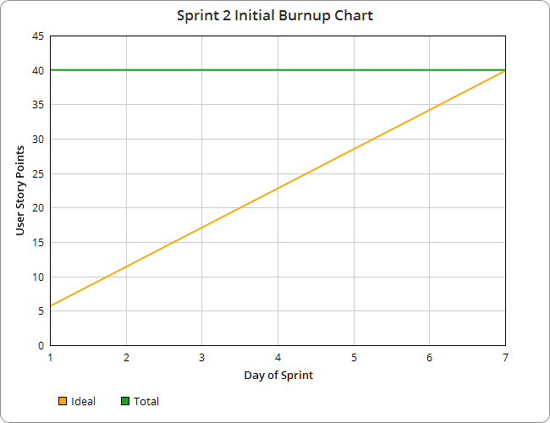

**Initial scrum board:**

|  |  |  |  |
| --- | --- | --- | --- |
| **User Story** | **To Do** | **In Progress** | **Done** |
| As a user, I’d like to be able to share my recipes so I can show my creativity with other users | |  | | --- | | Make a dialog for uploading user recipes to database |  |  | | --- | | Add to the save functions to upload to the database | |  |  |
| As a user, I’d like to be able to add other user created recipes to my list so that I have quick access to good recipes that others have created | |  | | --- | | Create a front-end function which will request the specific information from the server |  |  | | --- | | Implement ability to store locally so the requested information from the database is correctly stored |  |  | | --- | | Reflect the saved recipe on the list of sandwiches home page | |  |  |
| As a user, I’d like to view traditional recipes so that I have easy access to simple recipes. | |  | | --- | | Create a list of traditional sandwiches to choose from |  |  | | --- | | Write code for parsing the text file created in task 2 |  |  | | --- | | Create GridView for displaying the traditional sandwich recipes |  |  | | --- | | Load data from file to the GridView, displaying properly | |  |  |

**Scrum times:**

* Tuesday 12:30-4:30pm
* Thursday 12:30-4:30pm (with Sohum)
* Sunday 2:30-10:30pm (with Sohum)